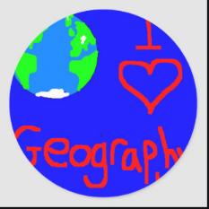
How to help your child to be a wonderful geographer when you are learning at home …

- Explore your local area …

- When you are out walking keep a record of what you see on the way. Select a different topic each time – for example – Day 1 How many red objects can we see? – Day 2 – What different types of vehicles did we observe?

- Play 1 – 10 on your walks. (1 street sign, 2 red cars 3 mummies with buggies etc).

- Play I Spy to investigate the features of places! A for Archway B for Bus etc
- Let children plan the route they want to follow when you are out walking.

- Let older children investigate route maps and help them to plan the route places that you visit.

- Play with your child with their small world lay outs - farm sets, train sets, dolls houses etc – talk about the layouts and rooms etc – what belongs where – where the tractors go etc.

- Board games, many of which have a geographical context, with them –Snakes and Ladders – Maze Games

- Sculpt local features with play dough, plasticine or modelling clay etc.

- Talk about places in films that you watch together – Jungle Book, Lion King, Over the Hedge, Ben Ten, Happy Feet and Ice Age 3 etc.

- Look at the food items that you are purchasing – note where they come from – look for the countries together in an atlas at home, or on Internet maps.

- Look at the labels in clothes items – where are the items made?

- Watch the weather forecast – even better listen to different radio channel forecasts. Did they get it right?

- Give your child a small patch of the garden to plant and tend – the magic of growing their own items.

- Be mini beast or habitat detectives in your back garden. Create your own garden eco tour. Star watch at night from homemade den.

