Geography
Learning at Home Activities

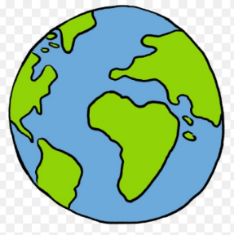

As a school we recently launched the "Where in The World?" initiative as part of the children’s Geography learning. We linked it with the Science Week theme "Our Diverse Planet". Each Year group has been designated a continent and initially the children and their teachers were asked to locate the continent and where it is in relation to us at Beaver Road and explore the diversity of the continents in terms of:
- climate
- food
- beliefs and culture
- impact humans have had
This is a project that could be continued as part of the children’s learning at home.

The children could make pictures, posters, leaflets, fact books or present the information about their continent however they choose.

BBC Bitesize have some really good Geography resources, some of which tie in with our continent study.

https://www.bbc.co.uk/bitesize/topics/zyhp34j
Information and resources suitable for Early Years and Key Stage 1, but also has good information on all of the continents.

https://www.bbc.co.uk/bitesize/subjects/zbkw2hv
Information and resources suitable for Key Stage 2

The continents allocated to each year group are:

Nursery and Reception - Oceania

Year 1 - Europe

Year 2 - Africa

Year 3 - Asia

Year 4 - North America

Year 5 - South America

Year 6 – Antarctica

Happy home learning!

